**(8223) INTRODUCTION TO COMPUTER ENGINEERING**

**ASSIGNMENT 1**

**SHOMIT BASU**

**STUDENT ID: 3294488**

**PART 3: AI IMPLEMENTATION**

**REFINING THE LOGIC**

In Step 3, I requested Copilot to "review my implementation step and suggest improvements or identify potential issues." I had previously developed a Word Code and a flowchart for the dual-sensor solution, but I was seeking input on its realism and completeness. Copilot provided an extensive analysis. It highlighted what was working well, such as the step-by-step logic, the separation of signals for vehicles and trains, and the inclusion of buffer time. Simultaneously, it highlighted improvements I had missed, such as specifying the sensor range, incorporating redundancy, and addressing edge cases like multiple trains or false positives triggered by the motion camera.

I also inquired about how this reasoning might be applied with actual hardware, particularly Arduino or Raspberry Pi. Copilot explained how sensors, motors, and LEDs could be integrated, and compared the two platforms in terms of cost, complexity, and capabilities. This gave me insight into how my design could transition from theory to practice.

Finally, when I asked for alternative solutions, Copilot suggested enhancements such as pressure sensors, RFID tags, smart traffic light integration, and wireless alerts. These broadened my perspective and showed me that my chosen solution is strong but could evolve further with technology.

In the following page, there are some screenshots from Copilot, where there are prompts and the AI answers.

IMPORVEMENTS TO MY LOGIC

REAL WORLD IMPLEMENTATION

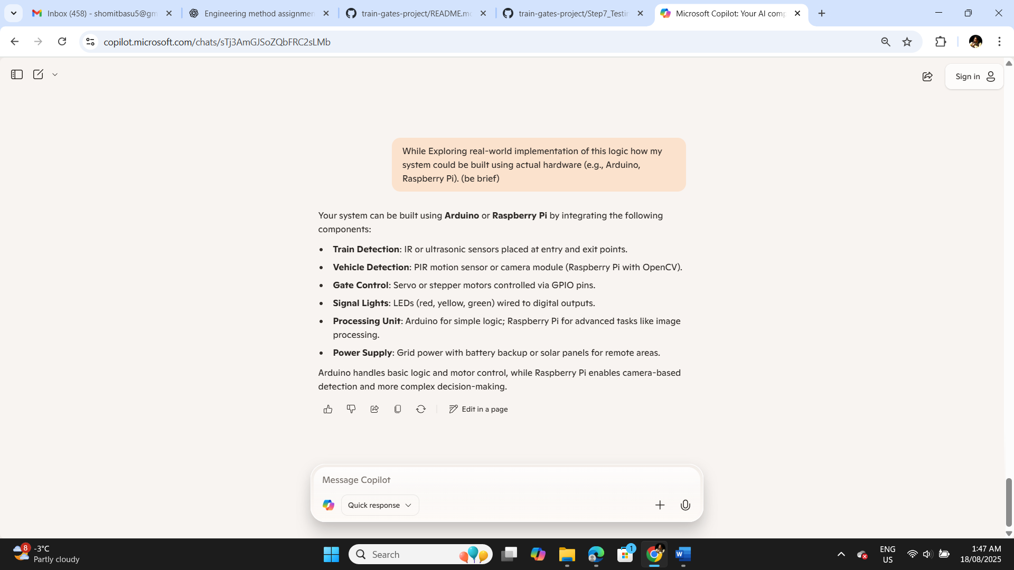

ALTERNATIVE SOLUTIONS

